**Project Proposal**

**Project Name:** Be Fit

**Team Members:**

Neelesh Saladi

Ravichander Reddy Goli

Rohitha Reddy Meda

Sai Rohith Gorla

**Project problem/issue:** As we all know in the current times it is very hard for people to go to gym and feel safe due to COVID Pandemic. To overcome this problem we are proposing this application BeFit, The Users of BeFit can get to choose a time slots in advance for a particular day and schedule the slots so that they can safely go to the gym and finish their exercise routine, where there will be limited number of people for the allotted Time slot. Users can also get choose various kind of “Exercise Routines” and they can schedule them.

Then after they will be displayed with the rate card as per their selection of which is different for every exercise routine. Then customers can view the billing amount details and can pay them at the Gym at the end of every month.

This will also help’s the gym management in getting the information of people who are using the gym on a specific time So that they can use this information for notifying other people incase of a Covid19 positive situation for a certain customer who used the gym in that time slot.

**Activities and their Purpose:**

**Sign up Activity:**

In Sign Up, User has to provide his/her basic information such as Username, E-Mail, Phone number, Password. By signing user can have easy and unlimited access to the application.

**Login Activity:**

In login activity, user can login by entering his/her credentials to their registered account. If the user was not able to login into the account by forgetting password, then they can reset their password by clicking on forgot password option and they will able to reset their password.

**Dashboard Activity:**

After logging into the app, user will be redirected into the dashboard activity. In this activity user can find different categories of workouts such as weight training, Cardio, Yoga, Power Training. By clicking on any of these categories user will be redirected to respective page.

**Calendar Activity:**

In calendar activity, user can view the available dates and hours of the slots and they can select the dates over there.

**Time Slot Activity:**

In this activity User will see different time slots of operating hours of gym, So that user can select specific time for going to the gym.

**Weight Training Activity:**

After selecting the required dates and time by user in calendar activity and time slot activity, if the user clicks on Weight Training option, he/she will be displayed with the slot availability for the selected date and time. If the slot is available then the user can book the slot. If the slot is filled then they will be displayed with filled option.

**Cardio Activity:**

After selecting the required dates by user in calendar activity, if the user clicks on Cardio option, he/she will be displayed with the slot availability for the selected date and time. If the slot is available then the user can book the slot. If the slot is filled then they will be displayed with filled option.

**Yoga Activity:**

After selecting the required dates by user in calendar activity, if the user clicks on Yoga option, he/she will be displayed with the slot availability for the selected date and time. If the slot is available then the user can book the slot. If the slot is filled then they will be displayed with filled option.

**Power Training Activity:**

After selecting the required dates by user in calendar activity, if the user clicks on Power Training option, he/she will be displayed with the slot availability for the selected date and time. If the slot is available then the user can book the slot. If the slot is filled then they will be displayed with filled option.

**Rate Card Activity:**

In this activity all the selected slots of the user will be displayed at the same place by calculating the total amount per each workout session. For every workout there will be different prices so the final amount will be calculated in the page for the User to check pricing details.

**Billing Amount Activity:**

In this activity, user will be displayed with name of customer and total amount he/she need to pay considered with rate card activity. Then the user should pay the amount at gym.

**Rough Sketches:**

**Signup Activity: Login Activity:**

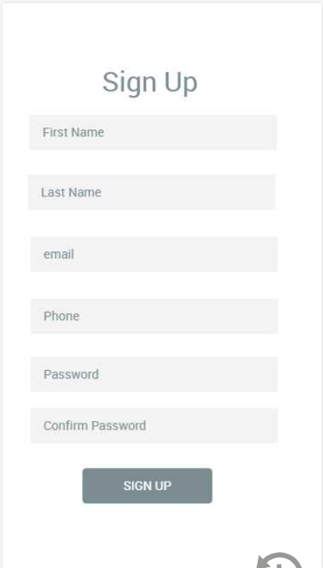 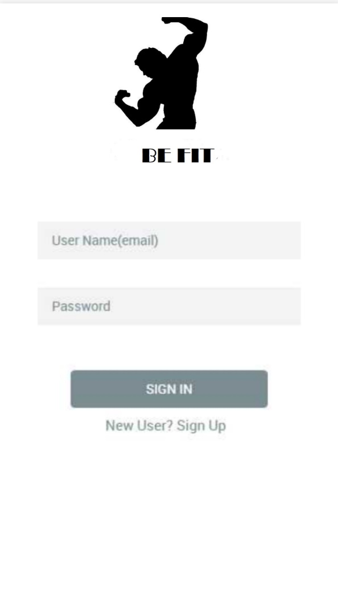

**Dashboard Activity: Calendar Activity:**

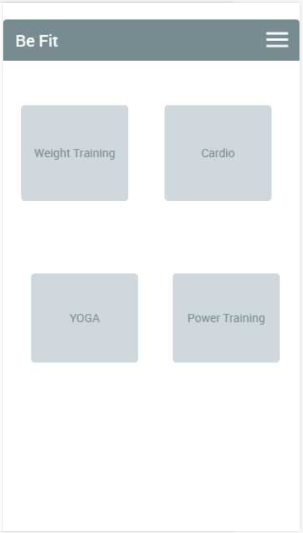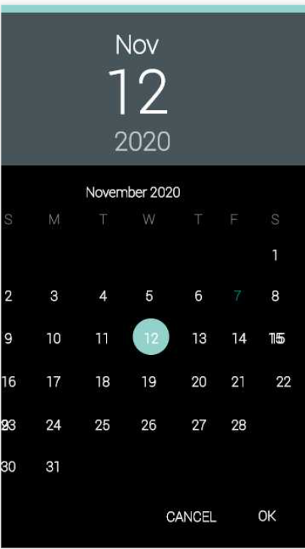

**Time Slot Activity: Weight Training Activity**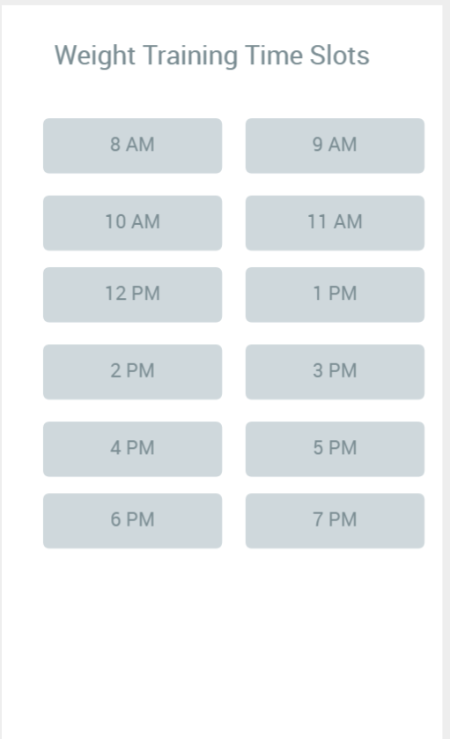 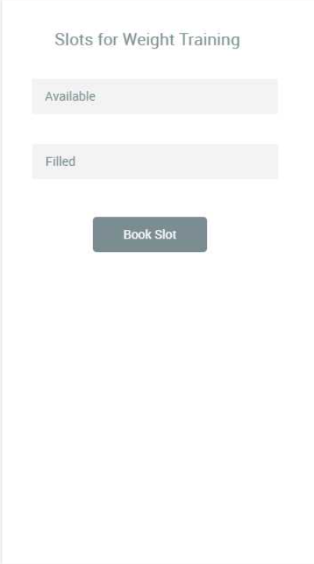

**Yoga Activity: Cardio Activity:**

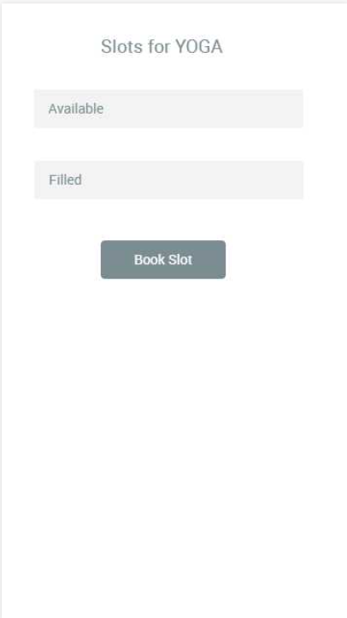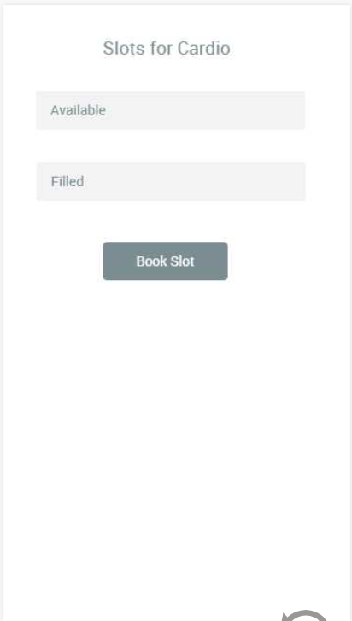

**Power Training Activity: Rate Card Activity:**

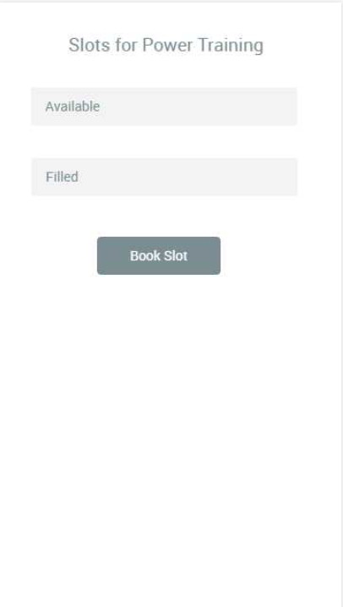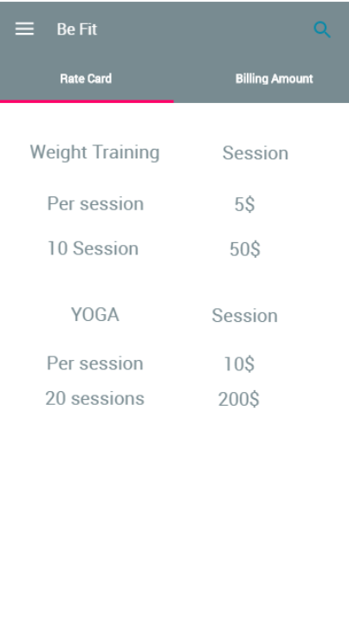

**Billing Amount Activity:**

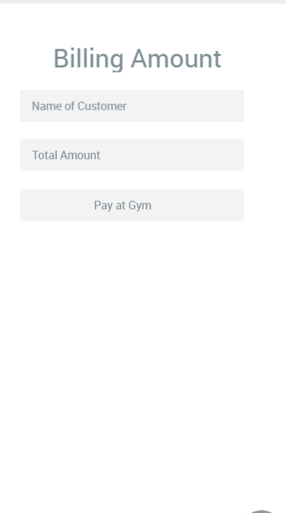

**Flow of Activities:**

